**WEEK-6**

**REACT**

**2.ReactJS-HOL**

**Create a React project named “StudentApp”**

**CODE:**

**Step1: Create new React project StudentApp**

Open command prompt or terminal in VS Code and run:

**npx create-react-app studentapp**

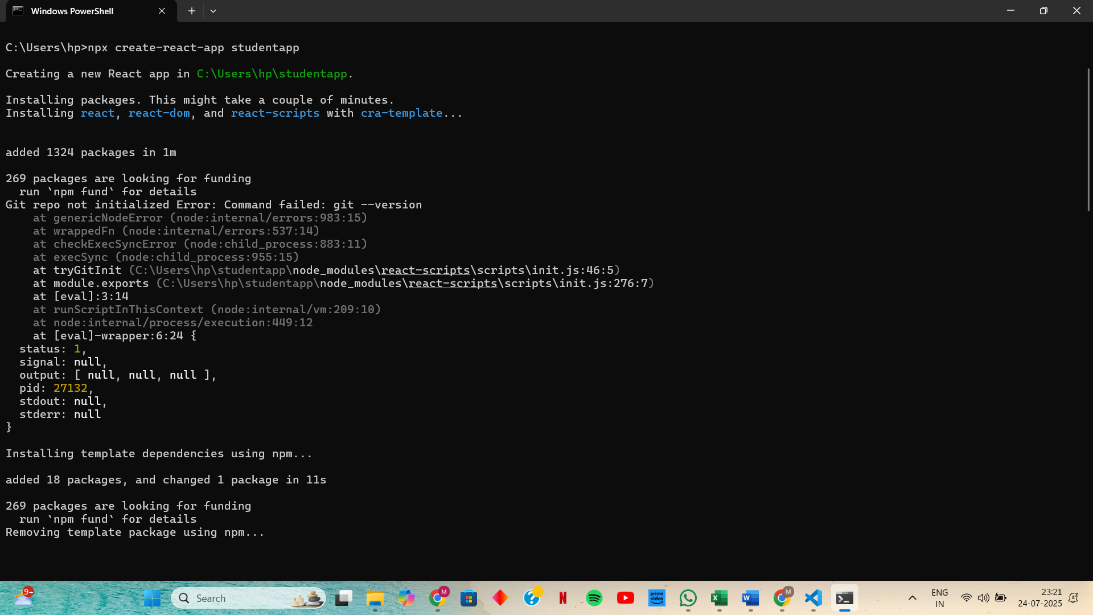

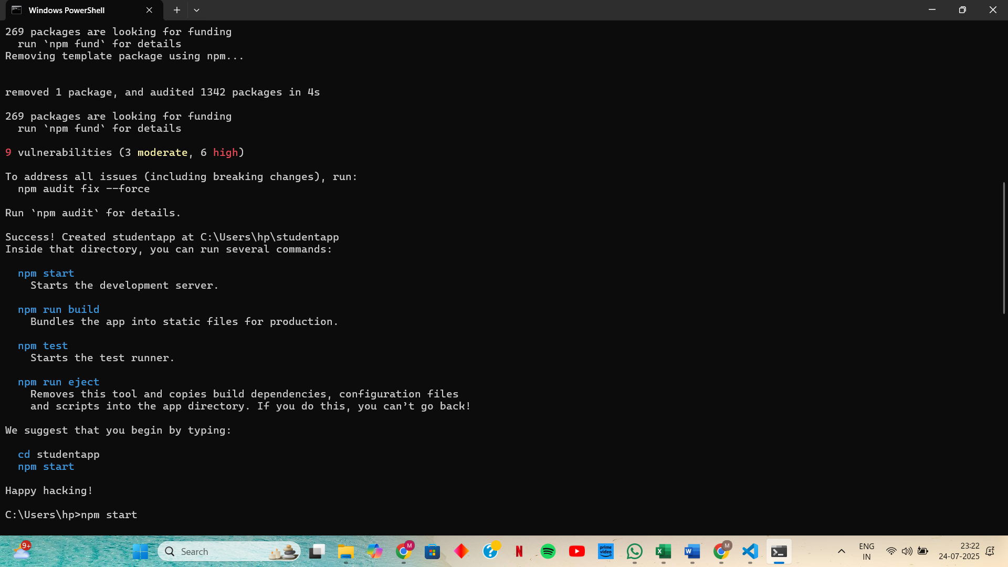

**Step 2: Navigate to the project folder**

**Step 3: Create Components folder under src in VS Code:**

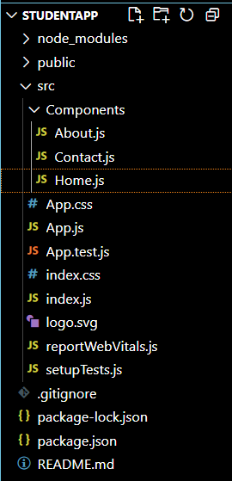

**Step 4: Create Home.js Inside src/Components**

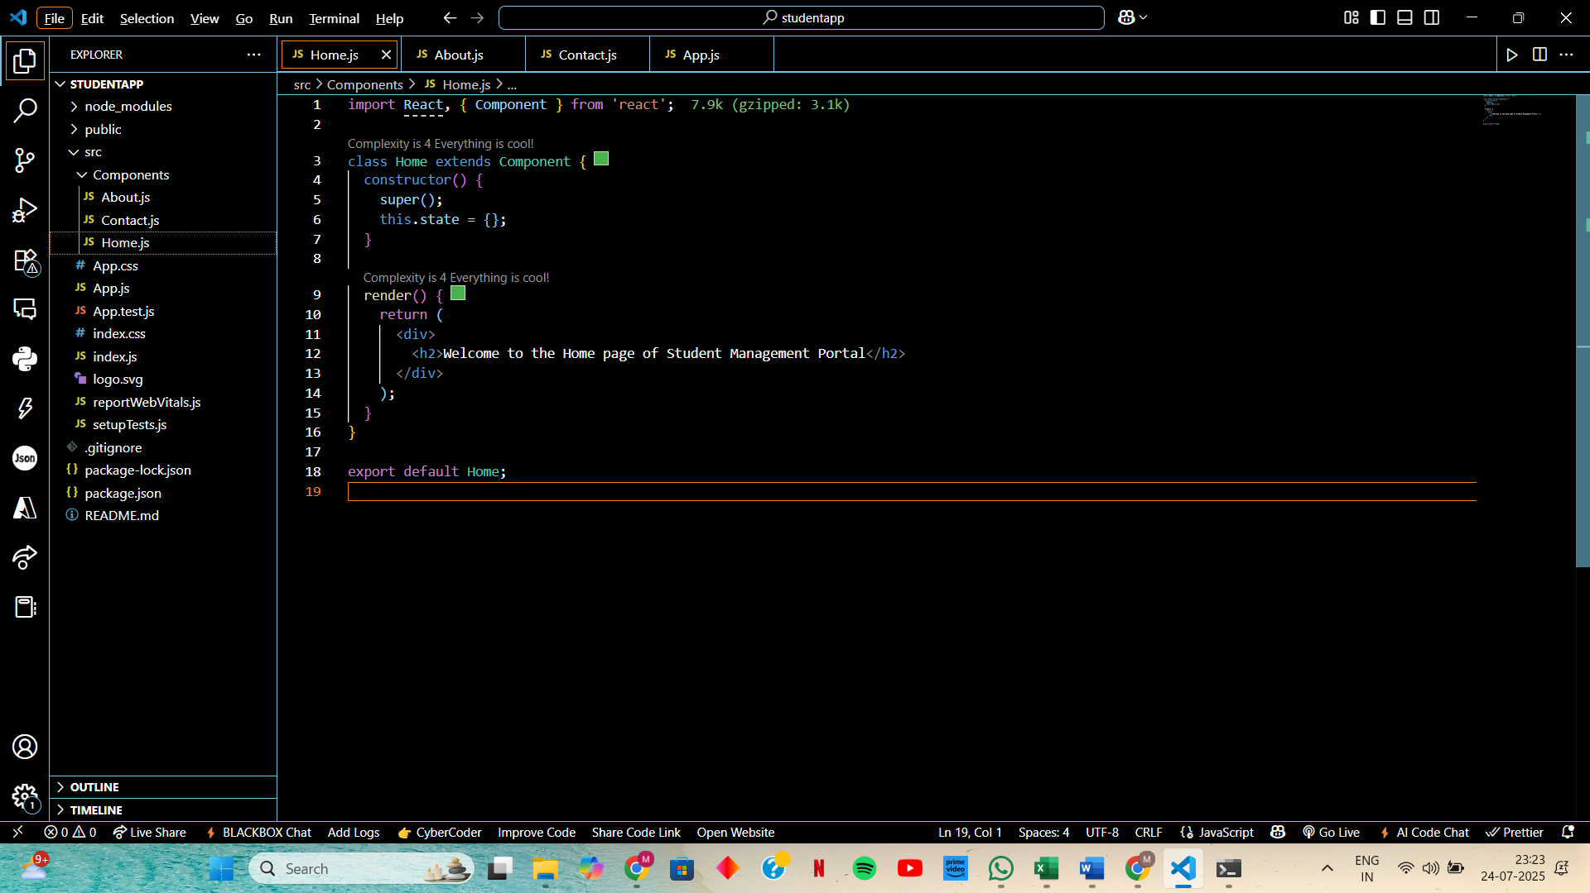

**Step 5: Create About.js inside src/Components**

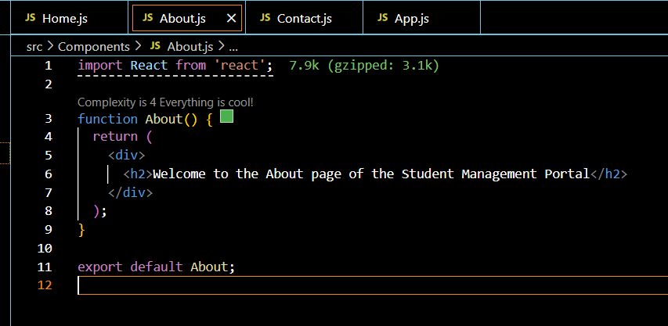

**Step 6: Create Contact.js inside src/Components**

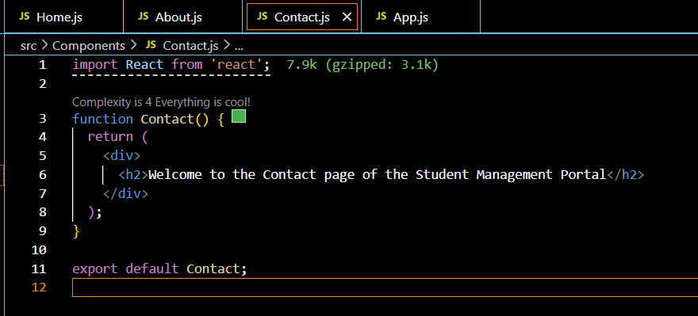

**Step 7: Edit App.js in src/App.js**

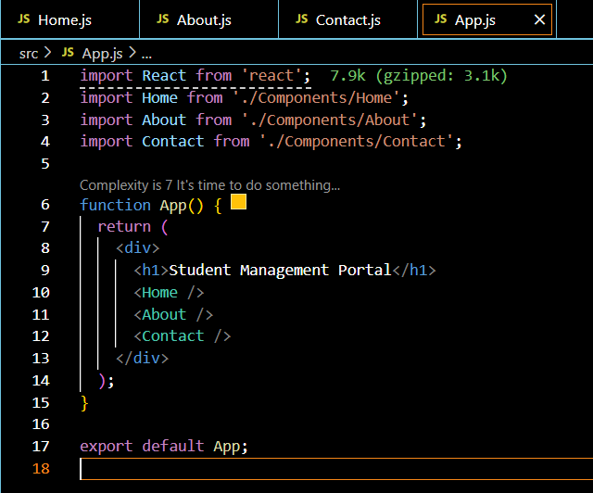

**OUTPUT:**

